Adding and editing external files

Contents

Overview 1

S3 file structure reminder 2

External files for JUICE modulette widget content 2

Editing an external file used by a content widget 3

Adding a new external file to a Refresher or Guided Practice 4

Adding a new external file to a Challenge game 6

Preparing a pdf for upload 6

External files for the module and modulette pages 6

Adding links to the module page introduction 7

Adding links to a modulette tab page 8

External files for JUICE Help 9

Editing JUICE Help’s external files 9

Adding an external file to JUICE Help 9

JUICE Help file paths 10

# Overview

The JUICE site includes links to **external files** in JUICE Help, on a few of the modulette challenge game tabs, and within the Refresher, Guided Practice, and Challenge game widget content files. External files are used for end-user documents such as the JUICE privacy policy or license agreement, the JUICE Picture it feature, text descriptions of images that are too long to include in the image alt text, and large embedded images.

External files are stored in S3, usually in the same directory as the JUICE page that uses them.

Important! All external file names must include extensions so that the browser knows how to open them.

Links to external files use variables to represent part of the path for the S3 bucket in which the external file is stored.

There are 3 different variables, each of which is supported in different locations in the site. The link format for each one as follows:

S3_BUCKET_/[bucket directory/file name.extension]

{{fileResources}}[bucket directory/file name.extension] (the missing slash symbol is intentional!)

S3_FILE_PATH/[bucket directory/file name.extension]

JUICE swaps the highlighted text for the URL and name of your S3 bucket, based on the values you define in the site config files.

These variables are supported in the following locations:

|  |  |  |
| --- | --- | --- |
| **Variable** | **Where can it be used** | **Name of file** |
| S3_BUCKET_ | Refresher, Guided Practice, and Challenge Game files (widget content files)  Module description  Modulette tab description | Individual widget files  module.txt  modulette.txt |
| {{fileResources}} | JUICE help | /docs/help/help.html |
| S3_FILE_PATH | Program definition—used to define paths to the help documents | /components/program-value/program-value-defaults.json  program.json |

## S3 file structure reminder

Module and modulette ids correspond to directory names in S3. For example,

* The files for module QS1 are found in the S3 directory QS1.
* The files for modulette QS1.1 re found in the S3 directory QS1/1.

Files for alternate (custom) programs are found in the specific alternate program’s directory, which is located in /programs.

Note that S3 uses the forward slash (/) for path names rather than the DOS backslash (\).

# External files for JUICE modulette widget content

The JUICE mini-lesson Refresher, Guided Practice, and Challenge game widget content files include links to external files. These are used for Picture its, text descriptions of images that are too long to include in the image alt text, and large embedded images.

For the most part, the external files for each widget content file live in the content file’s modulette directory in S3. In some cases, an external file is used across multiple modulettes within a module. In this case, the file lives in the module directory. A few files are used across many modules and modulettes—the Rounding Picture its are an example of this. These files are stored in the directory for the first module or modulette that used them.

You can find the location of an external file by inspecting its URL within the widget content file:

Example:

<a href=\"S3_BUCKET_/QS1/Unitsofmeasurement.html\"

This file lives in the QS1 directory in S3.

The widget content files support the S3_BUCKET syntax:

S3_BUCKET_/[bucket directory/file name.extension]

## Editing an external file used by a content widget

Most of the existing external files used by the content widgets cannot be edited directly. They are pdfs, images, or html files that use images to display the content.

The original editable source files for the images are available in the Content authoring documentation directory in two zip files:



Information about how each image was created is on a spreadsheet called *TRACKING for Picture its, embedded graphics, and ancillary content files* in the Overview and Try it graphic source zip file.

To replace an existing file with an updated version or your own alternate version, do the following:

1. Inspect the widget content file to find the external file’s URL
2. Upload the replacement external file to the correct location in S3. Make sure that you include the extension in the file’s name. For example: Understanding_percentage**.html**
3. Check the newly uploaded file’s metadata to make sure the content type is correct. If it is not set correctly, the file may not display properly:

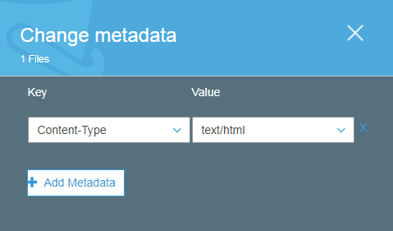

The content types used in JUICE are as follows:

HTML files text/html

PDFs application/pdf

Images image/png

Word doc application/msword

## 

## Adding a new external file to a Refresher or Guided Practice

Links to external files in the widget content are added using the widget authoring tools. See the documentation *Customizing and creating new mini-lesson files* for information on accessing the widget authoring tools. See the content authoring documentation and the *Picture it authoring tips* document for information on adding the picture it icon, links, and sizing ancillary file pop-ups.

The Refresher and Guided Practice widget authoring tools have an “insert link” dialog box:

1. Open the appropriate widget authoring tool to edit the content file.
2. Put your cursor where you want the link and click the insert image icon to open the “image” dialog box. Insert the Picture it icon using /images/picture_it.png as the URL. Do not add alt text, JUICE adds alt text that is appropriate for screen readers automatically:

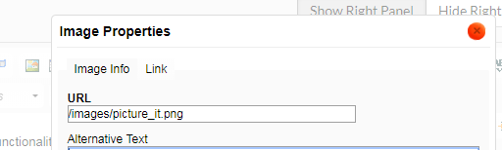

1. Save this, then type the link text next to the Picture it icon.
2. Highlight the link text, but do not highlight the Picture it icon. If you include the Picture it icon in the link text, screen readers will not read the appropriate alt text.
3. Click the insert link icon to open the insert link dialog box.

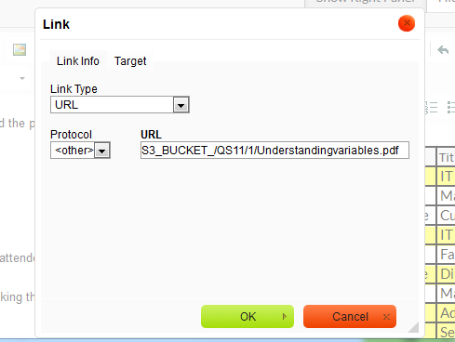

1. Add the URL for the external file using the S3_BUCKET_ syntax:

S3_BUCKET_/[bucket directory/file name.extension]

Example:

S3_BUCKET_/QS11/1/Understandingvariables.pdf

1. Set your link to open in a pop-up of the appropriate size.

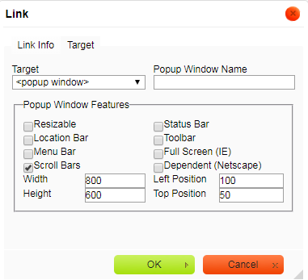

1. Save the file
2. Upload the external file to the directory you specified in the link, and set its content type in S3. In the example above, the file should be uploaded to the directory for module QS11, modulette 1.

If you want the external file to appear in JUICE Search, you must also update the Mongo DB Search tables. See the document *Using tags to improve JUICE Search* for more information.

## Adding a new external file to a Challenge game

The Challenge game authoring tools do not have an insert link tool. Instead, you just add html manually:

1. Open the appropriate widget authoring tool to edit the challenge game content file.
2. Add html for your link where you want it in the game text. Use the S3_BUCKET_ syntax:

<popup href=\"S3_BUCKET_/CS6/Minimumwage.html\">article about minimum wage<\/popup>

1. Upload the external file to the directory that you specified in the link, and set its content type.

## Preparing a pdf for upload

If you are uploading a PDF, you should set the “Title” property of the file. This will display in some browsers as the title of the document.

If this is not present, the full path file name will be displayed, or some other odd name depending on where your file came from.

# External files for the module and modulette pages

You can include links to external files in two locations on the JUICE module and modulette pages.

Module introduction area:

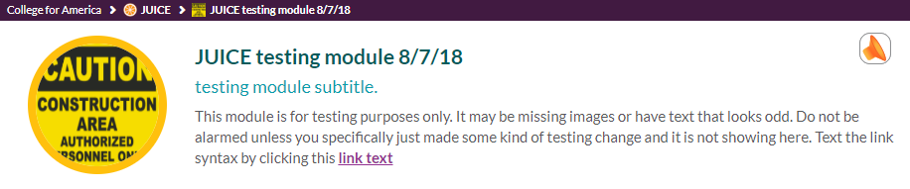

Modulette tab page:

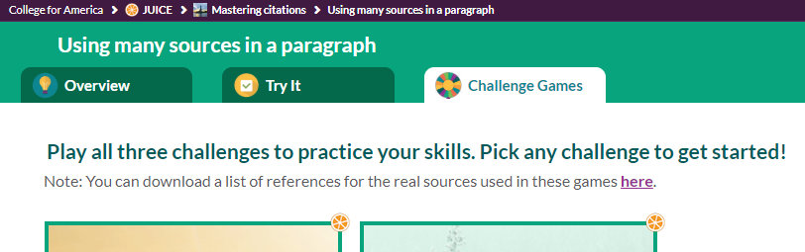

These links use the S3_BUCKET_ syntax:

S3_BUCKET_/[bucket directory/file name.extension]

Example:

<a href="S3_BUCKET_/JCS100/4/game_references.pdf"

## Adding links to the module page introduction

Add links to a module page introduction as follows:

1. In S3, navigate to the module’s directory. You can identify the directory by looking at the module URL:



This module’s directory is D1.

1. Download the module.txt file from the module’s directory, and edit it in a structured text editor such as Brackets.
2. Add html for the link syntax to the module.txt **description** field text

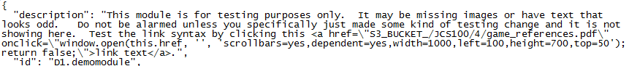

The html link syntax should use the S3_BUCKET_ variable:

S3_BUCKET_/[bucket directory/file name.extension]

<a href="S3_BUCKET_/D1/1/link_test.pdf" onclick="window.open(this.href, '', 'scrollbars=yes,dependent=yes,width=1000,left=100,height=700,top=50'); return false;">link text</a>

1. Save your changes and upload the revised module.txt file to S3.
2. Upload the external file to the directory you specified in the link, and set its content type in S3. In the example above, the file should be uploaded to the directory for module D1, modulette 1.

## Adding links to a modulette tab page

Add links to a modulette tab page as follows:

1. In S3, navigate to the modulette’s directory. You can identify the directory by looking at the modulette URL:



This modulette’s directory JCS100/3

1. Download the modulette.txt file from the modulette’s directory, and edit it in a structured text editor such as Brackets.
2. Add html for the link syntax to the **tab_subheader** field for the appropriate tab.

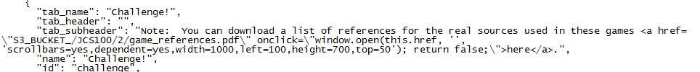

The link syntax should use the S3_FILE_PATH bucket variable:

S3_BUCKET_/[bucket directory/file name.extension]

<a href="S3_BUCKET_/JCS100/3/game_references.pdf" onclick="window.open(this.href, '', 'scrollbars=yes,dependent=yes,width=1000,left=100,height=700,top=50'); return false;">link text</a>

1. Save your changes and upload the revised modulette.txt file to S3.
2. Upload the external file to the directory you specified in the link, and set its content type in S3. In the example above, the file should be uploaded to the directory for module JCS100, modulette 3.

# External files for JUICE Help

JUICE Help is an html file. It uses external files for embedded images and end user documents such as the privacy policy and JUICE license agreement. The accessibility *Getting Started* guides are also external files.

JUICE Help supports the S3 bucket variable {{fileResources}}. The syntax is this:

{{fileResources}}[bucket directory/file name.extension]

There is no slash / after the closing bracket and before the bucket directory!

Examples from the JUICE Help file:

<img ng-src="{{fileResources}}docs/help/images/whatisjuice1_thumb.png" class="thumb" ng-click="showImage($event)" alt="juice module page showing the location of the page tour, mini-lessons and challenge wheel game. Click to enlarge. Enlarged version opens in a dialogue box.">

<a href="{{fileResources}}docs/help/accessibility_guide_windows.html" target=_new>Accessibility Getting Started Guide for Windows and NVDA (opens in a new tab)</a>

<a href="{{fileResources}}docs/privacy_policy.html" target=_blank>

## Editing JUICE Help’s external files

The external files used by JUICE Help are either html files, or image files. You may download and edit the html files. You must provide replacements for the image files.

1. Inspect the JUICE Help file to find the external file’s URL. The JUICE Help is in this S3 directory:

/docs/help/help.html

1. Find the external file in S3, download it, and edit if you can. Otherwise provide a replacement version.
2. Upload the replacement file to the correct location in S3 and set the content type.

## Adding an external file to JUICE Help

1. Download the JUICE Help file from this S3 directory: /docs/help/help.html and open it in a structured text editor such as Brackets.
2. Add the html for your new external file’s link using the {{fileResources}} syntax.
3. Save and upload the updated JUICE Help file to S3.
4. Upload the new external file to the directory you specified in the link, and set its content type.

# JUICE Help file paths

The location of the help files is specified at the JUICE program level. For core JUICE, the help paths are specified in this file, which does NOT live in S3:

/components/program-value/program-value-defaults.json

For alternate or custom programs, the help paths are specified in the program’s program.json file. See the documentation on *Customizing JUICE and creating alternate programs* for more information.

The help file paths in both files use the S3_FILE_PATH bucket variable:

S3_FILE_PATH/[bucket directory/file name.extension]

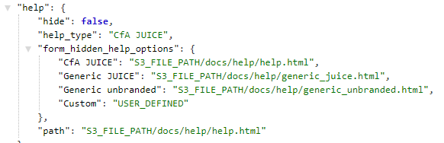

To update JUICE Help, locate the help file in the docs / help directory of S3, download it, edit it as desired and re-upload.

If you wish to change the directory where it is stored for core JUICE, access /components/program-value/program-value-defaults.json and update the path defined for “CfA JUICE”. Move the help file into this new location.

If you wish to change the directory where it is stored for a custom program, edit the custom programs program.json file.